Clauses
Main clause – A simple sentence that contains a subject and a verb. It makes sense on its own: I went to school.
Subordinate clause – Contains a subordinating conjunction. Adds detail to a main clause; is not a full sentence. The subordinate clause can appear at the start, end or middle of a sentence.
I went to school while my brother stayed at home.
Or
While my brother stayed at home, I went to school
Punctuation
Semi-colon (;) – joins two related independent clauses together
Dashes (–), brackets (), commas (,)
Used within a sentence to add additional information - Parenthesis
The cat (that didn’t belong to me) was black.
Determiners – A word before a noun and identifies the noun in further detail.
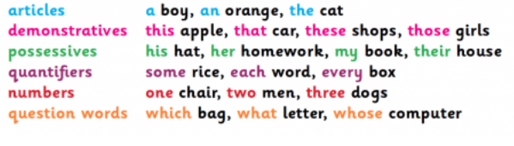
Passive and Active Voice
Active – Subject performs the action.
Passive – When the subject has something done to it. (By zombies)
The cat chased the mouse.
The mouse was chased by the cat.

Commands, Questions and Statements

Commands begin with an imperative
verb. Wash your hands.

Questions expect an answer in return.
Did you enjoy the trip?

Statements tell the reader something.
The leaves fall off trees in autumn.
Modal Verbs – Show degree of certainty or possibility.
could, should, would, might, often, ought, can
Comma
Inverted comma
Parts of speech
The child asked, “What are your plans for the weekend?”
Inverted comma capital letter closing punctuation
Subordinate Conjunctions
Joins a subordinate clause and
a main clause.
While
After
Because
Before
If
Though
Since
Because I go to school, I get to
learn about grammar.

I get to learn about grammar
because I go to school.

Tenses – Tells us when in time an action took place
Past | Present | Future
Simple Past  I walked  We saw  You ran | Simple Present  I walk  We see  You run | Simple Future  I will walk  We will see  You will run
Past Continuous/  Progressive  I was walking  We were seeing  You were running | Present Continuous/  Progressive  I am walking  We are seeing  You are running | Future Continuous/  Progressive  I will be walking  We will be seeing  You will be running
Past Perfect  I had walked  We had seen  You had run | Present Perfect  I have walked  We have seen  You have run | Future Perfect  I will have walked  We will have seen  You will have run

YEAR 6 SPAG KNOWLEDGE ORGANISER

More Punctuation
Hyphen (-) – Creates compound words to give a clear meaning.
The man-eating shark.
The man eating shark.

Apostrophes
For possession: Shows us that something belongs to the subject.
My Mum’s bag.
For omission: Shows us that a letter has been missed out to create informality.
Don’t do that.
Do not do that.

Subjunctive form/mood
A verb form to express wishes, hopes, commands, demands or suggestions.
If I were the prime minister…
I suggest that you take the deal.
Noun Phrases – Gives detail about a noun but does not contain a verb:
An ancient book in a leather sleeve was hidden in the library.
Coordinating Conjunctions
Joins two independent (main) clauses.
For
And
Nor
But
Yet
So
I like ice cream and I like cake.

