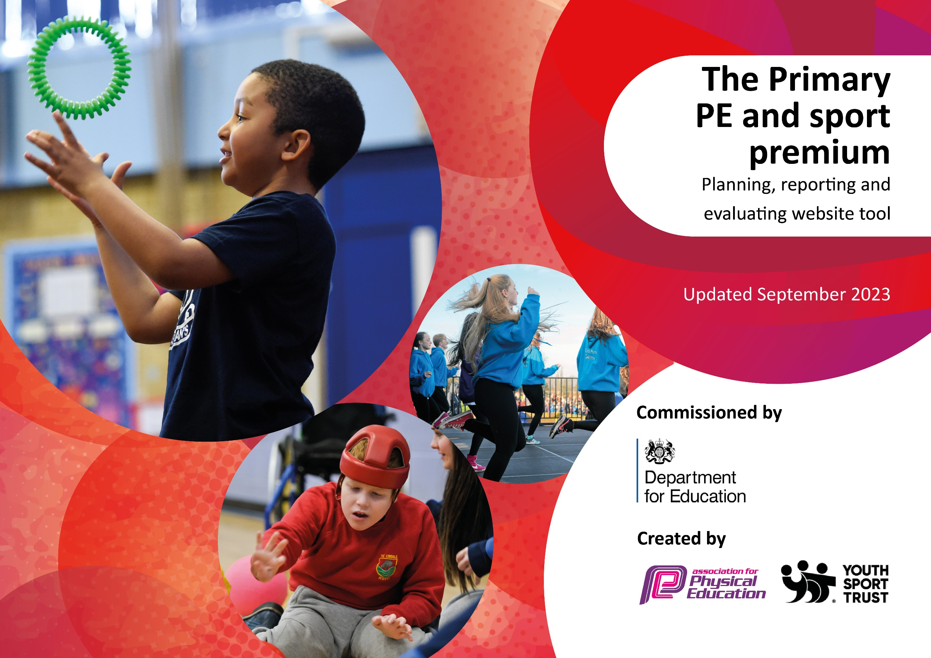

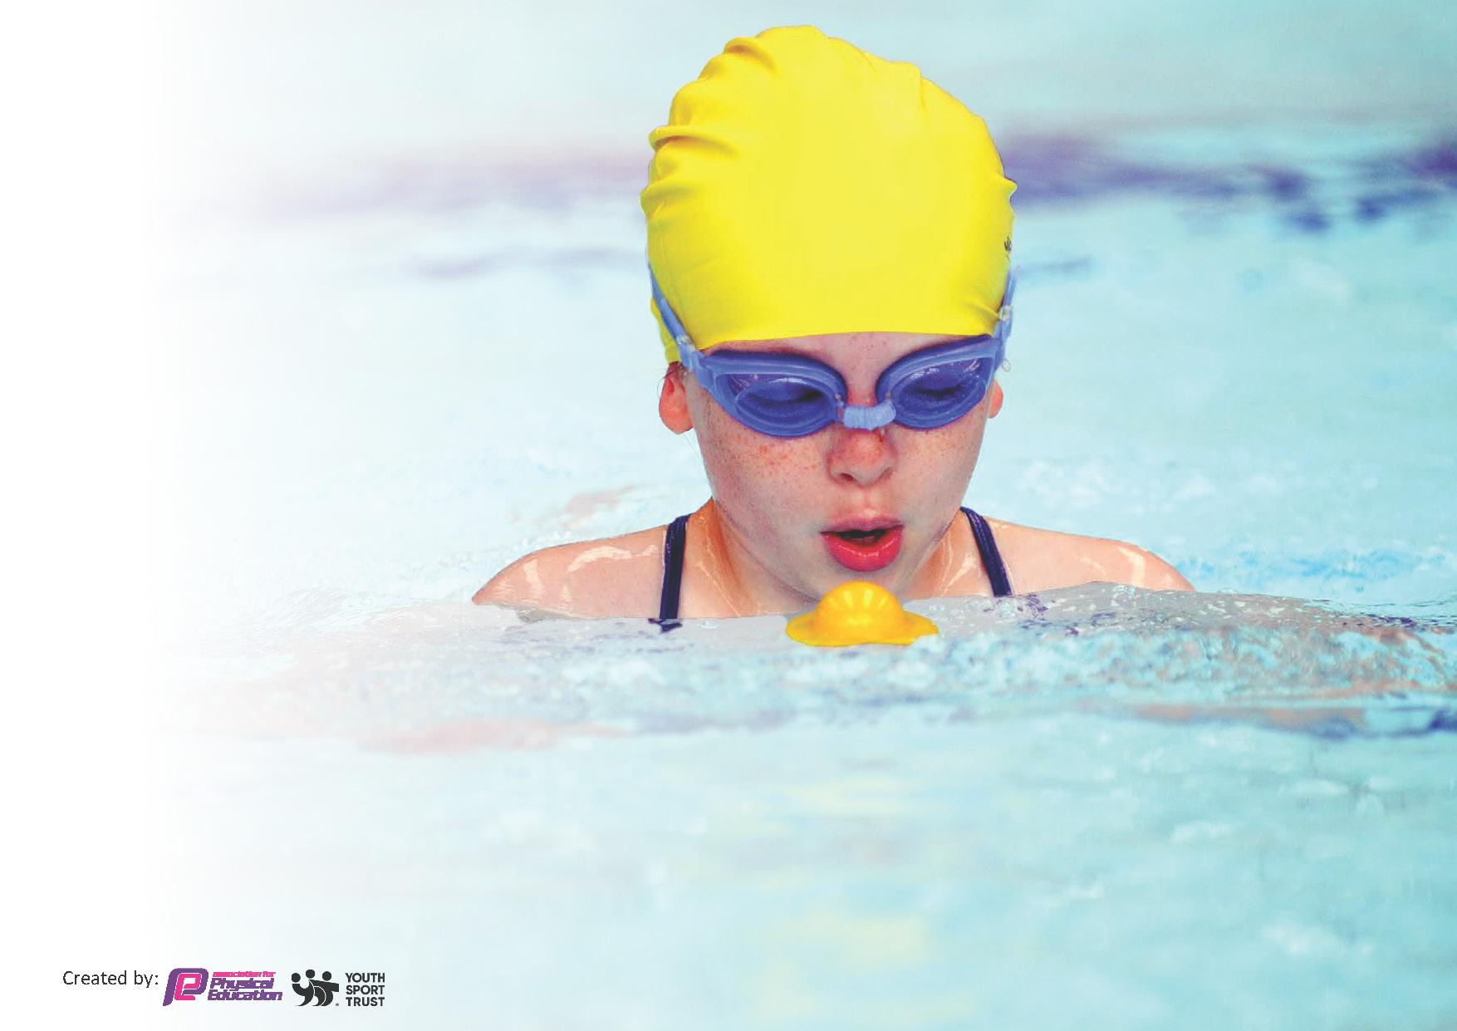
This template can be used for multiple purposes:
by:
- It enables schools to effectively plan their use of the Primary PE and sport premium
- It helps schools to meet the requirements (as set out in guidance) to publish information on their Primary PE and sport premium
- It will be an effective document to support Ofsted inspections enabling schools to evidence progress in Physical Education (PE) and evidence swimming attainment, which forms part of the PE National Curriculum. We would recommend schools consider
the Intent, Implementation and Impact of any spend, as examined within the Education Inspection Framework.

It is important that your grant is used effectively and based on school need.

Schools must use the funding to make additional and sustainable
improvements to the quality of the PE, School Sport and Physical Activity (PESSPA)
they offer. This means that you should use the Primary PE and sport premium to:

- Build capacity and capability within the school to ensure that improvements made now will benefit pupils joining the school in future years
- Develop or add to the PESSPA activities that your school already offers.

The Primary PE and sport premium should not be used to fund capital spend projects; the school’s core budget should fund these. Further detail on capital expenditure can be found in the updated Primary PE and sport premium guidance.

The Primary PE and sport premium guidance, outlines 5 key priorities that funding should be used towards. It is not

necessary that spending has to meet all the key priorities, you should select the priorities that you aim to use any funding towards.

Although completing this template is not a requirement for schools, schools are required to publish details of how they spend this funding. Schools must also outline what the impact this funding has had on pupils’ PE and sport participation and attainment and how any spending will be sustainable in the future. All funding must be spent by 31st July 2024.

The Department for Education has worked closely with the Association for Physical Education (afPE) and the Youth Sport Trust (YST) to develop this template and encourages schools to use it. This template is an effective way of meeting the reporting requirements of the Primary PE and sport premium.
Review of last year’s spend and key achievements (2022/2023)

We recommend you start by reflecting on the impact of current provision and reviewing your previous spend.

Activity/Action | Impact | Comments
Affiliation with HSSP | This helped the new PE lead develop their role, kept them up to date with key changes and gave many opportunities for CPD of staff. | We have joined HSSP core package for many years now, there are many benefits to being affiliated with them and we foresee that we will join the core package and look for different opportunities they offer going forward.
To join HSSP, sign up HDFSA, sign up to Cross country | There were a range of competitions for all age ranges from yr 1 -6, boys, girls , mixed and SEND or those that don’t attend football clubs etc outside of school | This has helped keep competition, children are excited to participate and are thrilled to be invited.
Markings on the school playground. | This has allowed children to be more active on the school playground by having different games marked on the playground, such as what’s the time Mr Wolf and a dance mat. The children really enjoy playing on these, especially when large amounts of equipment can’t be out, compared to when on the school field. | A nice colourful range of activities to encourage being active.
Review of PE equipment, safety checked and new PE Equipment purchased. | Children have a range of new sports equipment to utilize in PE lessons, this ensures that what they are using is safe and looks more appealing to use. | Ongoing review of what needs to be replaced. From this review – wall bars need to be replaced for safety concerns. Look to do this next year.
Daily mile | Continuation of daily mile across the school, encouraging staying active and the importance of movement. | Some repairs of the track are needed.

Key priorities and Planning
This planning template will allow schools to accurately plan their spending.

Action – what are you planning to do | Who does this action impact? | Key indicator to meet | Impacts and how sustainability will be achieved? | Cost linked to the action
HSSP - Core Package  HSSP - Cricket | The new PE lead joined Hunts Schools Sports Partnership Core Package. This package included a Networking Day, Update Workshops, subject leader support; including a subject audit and support with action planning.  Year 3 have benefit from a specialist teacher in PE leading their lessons as part of their CPD, this covers 2 classes that have an hour each for 6 weeks. | Key Indicator 1: Increased confidence, knowledge, and skills of all staff in teaching PE and sport. | HSSP Core Package is something that we have joined for many years now, it benefits us in many ways, including allowing children to attend many different sporting events.  CPD- looking at what areas of the curriculum are needed to be enhanced, last year some teachers felt that cricket was an area of the curriculum they were unsure of teaching so CPD for cricket has been put in place. | Core Package £950  £1050
Daily mile – track repairs  Lunchtime Equipment  Play Leaders | All children are able to walk on the track all year, in all weathers, there have been some repairs to the track this year to enable this to continue.  To purchase new equipment for use at playtime and lunchtime.  Year 2, 3, 4, 5 and 6 asked to learn to be a play leader. Then they will have activities organized for all children across the school to be a part of during lunchtimes. | Key indicator 2 -The engagement of all pupils in regular physical activity – the Chief Medical Officer guidelines recommend that all children and young people aged 5 to 18 engage in at least 60 minutes of physical activity per day, of which 30 minutes should be in school. | Children understand the importance of daily activity to enhance their health and mental health. This will continue into next year, set targets so that children aim to walk a certain distance and are enthused to walk more laps. Check with the Daily Mile website to see what the challenge is that they have set.  Purchase of equipment for lunchtime to encourage more children to be active during at lunchtimes and to improve mental health.  Then they will have activities organized for all children across the school to be a part of during lunchtimes. To help children remain active and improve their mental health. | £360  £515.98  £493.62
Park Run | Join a local park run to encourage activity outside of school and involving more family members. | Key Indicator 3: The profile of PE and sport is raised across the school as a tool for whole-school improvement | Contacting of local park runs to see if we can join the run, these are free events which should help attract people to come and join in. | NO COST but we had to ensure staff from school could volunteer to support the event.
PE Equipment  Sports coach – after school clubs and holiday facilities.  Bikeability | To purchase new equipment for enhancing PE lessons for all children, including purchase, removal and fitting of wall bars.  Our sports coach to provide clubs term time outside of school time.  Our sports coach has also been employed to support our Holiday provision for CPD of staff members in the provision.  Children in y6 and year 4 | Key indicator 4: Broader experience of a range of sports and activities offered to all pupils. | Purchase of equipment allows pupils to access the sport and have the ability to achieve their full potential.  Ensuring our equipment meets standards ensures that our children are still able to use the equipment in order to access high level PE lessons.  To enable and encourage more children to be active outside of school time and to offer a variety of different sports  To support our Holiday provision and provide CPD for staff members in the provision.  To encourage safe cycling whilst out and about and show children the enjoyment of cycling. | £631 +  £8131.55  £800 – Holiday club  £240 – after school clubs  NO COST
Inter House at the end of every half term  HSSP Core package competiton  Cross Country  Hunts football  Minibus to events  Staffing for events  Support from sports coach for sports day | All children across the school from y1 – 6, boys, girls, mixed competitions including SEND.  We have inter school competitions whereby the skill that is being taught in PE and has been practiced at game level, can be put further into practice within tournaments.  Intra school competitions, offer a wider range of sporting competitions to attend and the chance for children to represent their school.  Our Sports Coach supported us with the running of the day | Key indicator 5: Increased participation in competitive sport. | Children have been encouraged to participate with many more competing than wanted to at the beginning of the year.  Children put the skills learnt from PE lessons into a practice in game.  The Sports Captains have taken on the responsibility well, encouraging their teams and organising the event  This helped to ensure we had enough adults for the different events and ensured that the day ran smoothly. | NO COST  £42.65  £20  Minibus: £3210  Staffing costs:  £369 (Specialist teacher for SEND Panathlon’s x3)  £ 1924.50 staffing  £160

Key achievements 2023-2024 £18,850 – spent £18,898.
This template will be completed at the end of the academic year and will showcase the key achievements schools have made with their Primary PE and sport premium spending.

Activity/Action | Impact | Comments
All children will be taught 2 hours of PE lessons taught weekly.  In EYFS, children have one formal PE lesson a week and three 20 minute sessions. The focus in all lessons is largely  on children’s gross motor skills development. Another focus of physical development in early years is also on children’s health, children are taught to keep themselves safe, to  manage their own risk and about the importance of keeping their bodies healthy.  From Year 1 through to year 6, children have two one hour sessions in PE, this is organised into indoor and outdoor learning and skills are progressed upon each year so that they can play in game like situations. | Children are excited about going to their PE lessons, they eagerly anticipate what new skills they will be learning and are able to build upon previous learning to enhance their new learning. | Ensure that there is continuation of children completing 2 hours of PE the following year, following the whole school curriculum planning and using Cambridgeshire scheme of learning to ensure high quality lessons are being taught across the school.
HSSP - Core Package  The new PE lead joined Hunts Schools Sports Partnership Core Package. This package included a Networking Day, Update Workshops, subject leader support; including a subject audit and support with action planning.  Competitions  HSSP  Hunts FA  Cross Country | This has ensured that the new lead had support in place to be kept up to date that they were up to date with relevant information, was clear about what should be in place to ensure a high standard and variation of PE provision is across the school.  The above core package also included access to many intra school sports competitions that meant that both boys and girls from year 1 to year 6 could participate in a range of competitions, including those that have SEND needs.  We also joined the Hunts FA so that we could join the local schools league and compete in tournaments aimed at both boys and girls from Key Stage 2.  Additionally, we attended the Cross Country competition entering 4 teams from year 5 and 6.  To ensure that children can get to and from the events.  Staffing of 1 qualified teacher and 1 TA – both members of staff are first aid trained. | Signed up for next year, things are ever changing in the curriculum and they feed this information to us.  Join the different competitions to ensure that a range of different sports are offered to our children.
Audit of current sports equipment and purchase of new equipment for Sports Day, lunchtimes and wall bars for the hall: | Purchase of equipment allows pupils to access the sport and have the ability to achieve their full potential.  Ensuring our equipment meets standards ensures that our children are still able to use the equipment in order to access high level PE lessons.  To ensure that KS1&2 and supports a range of activities across the school. This includes specific equipment for Sports Day so that we have immediate access to this when needed and can ensure that it is in condition. | Continue to check equipment for PE so that it is up to date and at a good enough standard for high level PE teaching.  Continue to look at equipment for lunchtimes to encourage our children to stay active at these times.
Kit for football: £750  Kit for other competitions | To order new kit for football as ours has bits missing or is not in good condition. (This was subsidized by ……)  A kit for other competitions that aren’t football so that we all match, as our PE kit is based on house teams ready for Sports Day. | Kit purchased for football but through free of charge.  Kit not purchased for other competitions but we have used some plain white t-shirts with the school emblem on – there aren’t many of these so these could be purchased going forward.
CPD  HSSP – Cricket CPD | Half a day CPD for year 3 teachers in Cricket led by a specialist teacher who is part of HSSP – this for 6 weekly sessions that are an hour in length for 2 teachers – totaling 12 hours. | Ask staff what area of PE needs a focus next year based upon confidence, we have 2 new teachers next year that may benefit.  There needs to be some Dance CPD as there are many new staff.
Play leaders: | Training of children in year 2,3,4,5 and 6 (66 children) to become play leaders of different activities, to encourage being active on the playground during break and lunch times. | Children have enjoyed this and children have things to play at lunchtime – continue this going forward.
Daily Mile  Repair of track for daily mile: | Children understand the importance of daily activity to enhance their health and mental health. | Repair of track means that we can continue with this.
Park Run | Join a local park run to encourage activity outside of school and involving more family members. | We attended one Park Run which had a high turnout of pupils. Unfortunately, we were unable to attend more this year as many had been cancelled due to poor weather conditions. But this is something that will hopefully happen again in the new academic year.
Interhouse including sports day: | Many children from y1- y6 were able to participate in interhouses that were organized this year ,including SEND children, This gave the children opportunity to use the skills taught in their lessons in real game situations.  EYFS were also able to compete in Sports Day | This to continue into next year, look at how to include EYFS earlier on in competition – maybe similar to a multiskills festival that is run by HSSP for y1/2.
Bikeability: | Understanding how to stay safe while cycling on roads for y4 and y6. | The advanced level Bikeability for y6 children who are likely to cycle to their secondary school.  Look at Balanceability for EYFS.

Swimming Data
Meeting National Curriculum requirements for swimming and water safety.
Priority should always be given to ensuring that pupils can perform safe self-rescue even if they do not fully meet the first two requirements of the National Curriculum programme of study

Question | Stats: | Further context  Relative to local challenges
What percentage of your current Year 6 cohort can swim competently, confidently and proficiently over a distance of at least 25 metres? | 80% | There are only a small number of children that can’t swim 25m, therefore it would be a large amount of time out of the curriculum to send them to these swimming sessions, especially as our swimming teacher is our year 6 teacher and there is a greater need for her to remain in class.  Those that can’t, have been invited by Cambridgeshire County Council to attend Every Child a Swimmer catch up programme.
What percentage of your current Year 6 cohort can use a range of strokes effectively [for example, front crawl, backstroke, and breaststroke]? | 80% | The amount of children that can swim these strokes is the vast majority and it is only those that haven’t attended swimming lessons outside of school that have not got these strokes.  Those that can’t, have been invited by Cambridgeshire County Council to attend Every Child a Swimmer catch up programme.

What percentage of your current Year 6 cohort are able to perform safe self-rescue in different water-based situations? | 80% | Many children participate in lessons outside of school and this is part of their teaching within the lessons they attend.  Those that can’t, have been invited by Cambridgeshire County Council to attend Every Child a Swimmer catch up programme.
If your schools swimming data is below national expectation, you can choose to use the Primary PE and sport premium to provide additional top-up sessions for those pupils that did not meet National Curriculum  requirements after the completion of core lessons. Have you done this? | No | We did initially, however those that can’t, have been invited by Cambridgeshire County Council to attend Every Child a Swimmer catch up programme.
Have you provided CPD to improve the knowledge and confidence of staff to be able to teach swimming and water safety? | No | This was not relevant this year.

Signed off by:

Head Teacher: | (Name)   Michelle Heather
Subject Leader or the individual responsible for the Primary PE and sport premium: | (Name and Job Title)  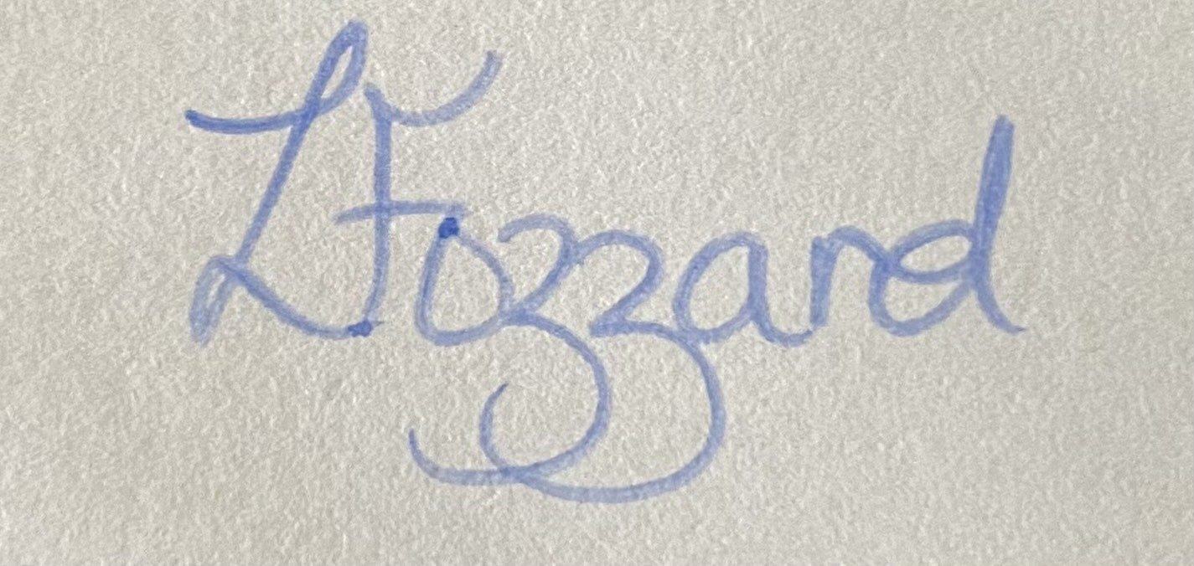 Laura Fozzard, PE Lead
Governor: | (Name and Role)   Hamish Anderson, Chair of Governors
Date: | 15/07/2024

